**Preferred Government Staffing, Inc. CAPABILITIES STATEMENT**

## CORE COMPETENCIES

* Occupational Therapists
* Physical Therapists
* Speech-Language Pathologists
* Audiologists
* Medical & Radiation Physicist
* Sonographer
* Dosimetrist
* Radiation Therapist
* Respiratory Care Professionals
* Radiological Technologist
* CT Tech
* MRI Tech
* Licensed Clinical Social Worker

## DIFFERENTIATORS

* Certified Small Micro Business
* Certified Service Disabled Veteran Owned
* FSS 621I 36F79721D0201
* In partnership with WOSB Preferred Healthcare Registry

## Small Verified Vendor Seal

Integrity, Commitment, Advocacy, Respect, and Excellence ICARE

**Government Staffing Services.**

**Services**

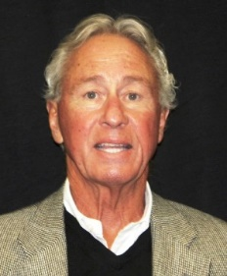

DAN DENTON, CEO

U.S. Army Infantry 1967-1970 Service Disabled Veteran

Ph:951-443-9443

Fax: 800-787-6762

[Dandenton1@cox.net](mailto:Dandenton1@cox.net)

dan@preferredgovernmentstaffing.com

|  |  |
| --- | --- |
| **SINs** | **NAICS Codes** |
| 621-035 | 561311 |
| 621-037 | 561320 |
| 621-031 | 621034 |
|  | 621111 |
|  | 621330 |
|  | 621340 |
|  | 621399 |

# Certified SDVOSB

# GSA: 36F79721D0201

# DUNS: 080642814

# CAGE: 7WQ91

# CA Inc: C4009360

**SAM Unique Entity ID**

**HQA7K8CCJBJ4**